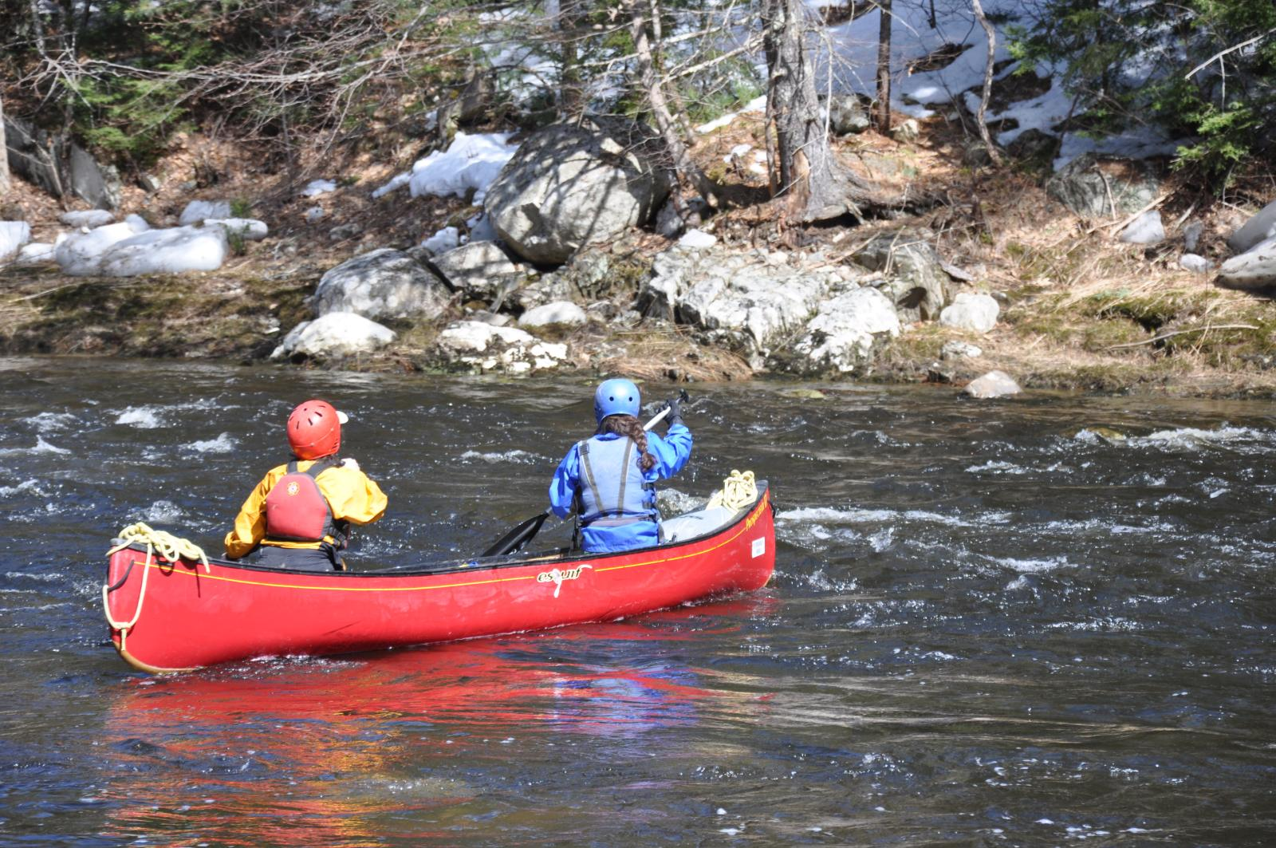ICF Canoe Kayak Wildwater World Championships La Plagne 2012 : This one is coming too...seriously :-)

ICF Canoe Kayak Wildwater World Championships La Plagne 2012 : This one is coming too...seriously :-)

**The 47th Beavan Challenge**

**Friday 3rd October to Sunday 5th October 2025**

|  |  |  |  |  |
| --- | --- | --- | --- | --- |
| **Troop/Unit: District:** | | | | |
| **Name of Leader in Charge: Email Address:** | | | | |
| **Address of Leader in Charge:** | | | | |
| **Leaders Home Tel No:** | | **Leaders Mobile No:** | | |
|  | | | | |
| **I wish to enter the following:** | | | | |
| **Age Sections** | **No of Teams** | | **No of Competitors Entering** | |
| **Junior Scouts/Guides Teams of 4 (all 10.5yrs to 12.5yrs)** |  | |  | |
| **Senior Scouts/Guides Teams of 4 (12yrs to 14.5yrs can mix younger members in)** |  | |  | |
| **YL/Explorers/Rangers Teams of 4**  **(Age 14 – 18)** |  | |  | |
|  | | | | |
| **Total No of Teams:** | **Entry Fee £ 95 per team (Includes camp fees)** | | **Total: £** | |
|  | | | | |
| **Total No of extras Camping: (**Leaders & Support)  (Camp Fees for whole weekend are £9.20 per Leader/Helper/YL) | | | **No of extras Camping: _____** | **£** |
| **Total: £** | |

***Please pay by BACs transfer (Preferred option) to Sort code 20-50-36 Account Number 60403865 – use your troop / unit’s name as the reference - we can take* a Cheque *- cheques made payable to Geoffrey Beavan Challenge please***

**As Leader in Charge, I agree to abide by the Challenge Rules, take full responsibility for the abilities of my team(s) and understand that should my team(s) not be correctly equipped or judged to be competent for either the Hike or Canoeing they may be withdrawn by the activity Leader.**

**Signed: ................................................................ Leader in Charge Date: .....................................**

Once completed, please email this form to Sue Flush @ [sue.flush@gmail.com](mailto:sue.flush@gmail.com) and send payment via BACS or chq to 1 Lawford Drive, Heswall, Wirral CH60 2TD – **Registration closes once event is fully booked.**

Team lists etc are to be sent via email to Sue ***NO LATER than Monday September 8th 2025***

Full Event Information will be sent back only on receipt of this fully completed form and full payment by cheque or Bacs – applications will not be accepted without both - Refunds will only be considered for teams withdrawn more than 2 weeks before the competition, please let us know about any changes as soon as possible.

***Organised by West Wirral District on behalf of Merseyside County Scout Council***